**Effective Algorithm**

Repeat Until a MaxWord is found than;

Iterate the Following Steps until all Letters on the Board has been assessed;

Start on a letter on the board than

Look at positions that are in either direction of the Starting position, produce all the possible Dictionary words that can be made from that substring. For example the word tone, look at possible words in direction of the empty slots what letters could go in to make a word

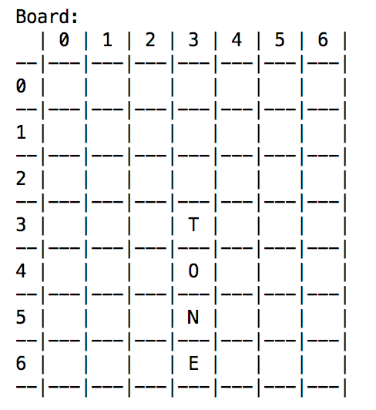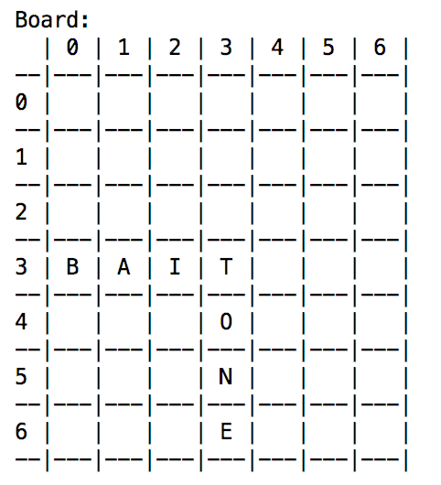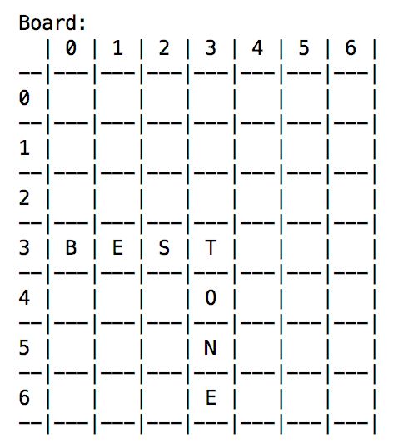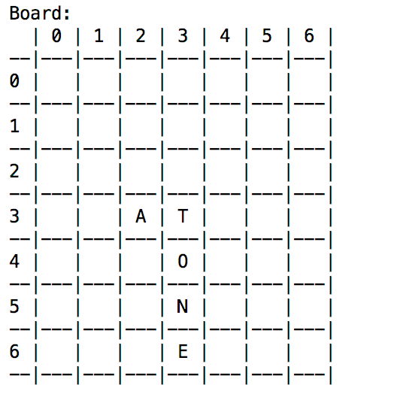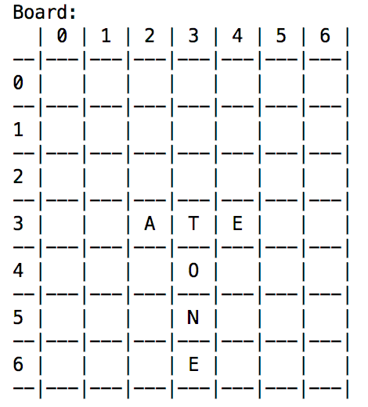

Create a List of words that can be made from this starting position. (In the example above it is from the ‘T’)

Move along each possible starting position such that the entire Board Tiles have been covered.

From the list of the possible words, find the highest one, this should be the maximum scoring word.

**Justification:**

It is more efficient than the Brute Force method because the Possible Words list would be significantly smaller, this is because the efficient method ignores invalid possibilities in cases where there are 2 letters on the Board that are being used. The efficient method considers the position of these 2 letters whereas the Brute Force method doesn’t therefore create a much larger list of Possible Solutions compared to the Efficient Method where the number of slots between the 2 On Board letters must stay the same when investigating for a possible Solution. For the example below the E and T must have a letter in between when investigating a Maximum solution and A and N must also have a letter in between when investigating a Maximum solution.

